**Project Report on**

**Notification System**

**Submitted to Punjabi University, Patiala**

**In fulfillment of the requirement for the degree of**

**Master of Computer Applications**

**(MCA-4th semester)**

**Project Guide Submitted By:**

Dr. Maninder SinghMohit Bansal (16071202)

Dr, Gagandeep Kaur Mohit Kumar (16071205)

Sanjib Kumar Mandol(16071214)



**Department of Computer Science**

**Punjabi University Patiala**

**Session: 2017-2018**

**NOTIFICATION SYSTEM**



**CERTIFICATE**

This is to certify that this project “ **Notification System**“ submitted to Punjabi University Patiala in fulfillment of the requirements for the degree of Master of computer Applications, is a hard work carried out by **Mohit Bansal, Mohit Kumar and Sanjib Kumar Mandol** under our supervision and no part of this work has been submitted for any other degree. The assistance and help received during the course of work has been fully acknowledged.

**Project Guide**

Dr. Maninder Singh

Dr. Gagandeep Kaur

**ACKNOWLEDGEMENT**

Foremost, we would like to express our sincere gratitude to Almighty for giving us courage to bring up this project successfully. Our sincere thanks goes to Dr. Maninder Singh and Dr. Gagandepp Kaur . They has been of great help in carrying out the project work and is accredited with courteous thanks.

We express gratitude to other faculty members of DCS of Punjabi University Patiala for their intellectual support throughout the project. Last but not the least we would like to thank our family and friends for the sleepless nights we were working together before deadlines.

**Mohit Bansal**

**Mohit Kumar**

**Sanjib Kumar Mandol**

**Date: 26.04.2018**

**ABSTRACT**

**Notification System** is system in which User will send Notifications to all other people he want. This System Basically send Information through Email and SMS. Admin can also add, delete and Update record in database.

**TABLE OF CONTENTS**

|  |  |  |  |
| --- | --- | --- | --- |
| **Sr no.** | **Contents** | **Page no.** | **Signature** |
| 1. | Chapter 1  Introduction:-   * 1. Purpose   2. Intended Audience   3. Product Scope   4. Project Features   5. Feasibility   6. System Requirements   7. Software Requirements   8. Team Structure | 1-2 |  |
| 2. | Chapter 2  System Development:-  2.1 Project Management  2.2 System Analysis and Design (DFDs)  2.3 System Environment | 3-5 |  |
| 3. | Chapter 3  Design and Implementation:-  3.1 Discuss various classes that are used  3.2 Database Design  3.3 Snapshots of system | 6-8 |  |
| 4. | Chapter 4  Testing:-  4.1 Verification  4.2 Validation  4.3 Testing  4.3.1 Unit Testing  4.3.2 Integration Testing | 9-10 |  |
| 5. | Chapter 5  Project Legacy:-  5.1 Current Status  5.2 Problem Faced  5.3 Limitations  5.4 Future Enhancements  5.5 Conclusion | 11-12 |  |
| 6. | Reference /Bibliography | 13 |  |

**Chapter 1**

**Introduction**

* 1. **Purpose**
* To Notify employees or students about particular information of an organization through E-mail or SMS or both.
  1. **Intended Audience**

Mainly intended audience of this system is server managers who can send E-mail or SMS to a particular person(employee or student).

* 1. **Product scope**

This is for desktop application which require internet connection. This is an online project. This project is for single user. This system can be deployed on local servers of an organization to notify their employees.

* 1. **Project features**
* Easily send messages or E-mails to the concerned person about particular information.
* Saves time and money.
  1. **Feasibility:-**
     1. **Technical feasibility** : To develop this product ASP.NET will be used and IDE’s also be used like: visual studio.
     2. **Economic feasibility :** The product is Economical feasible because free tools(software) and requirements are available.
  2. **System Requirements:-** : For this system a meeting was held with a Person who want to notify concerned person or group of persons about particular information. Then those requirements were analysed and put in a proper flow chart. Then according to requirements sources needed are collected.
     1. **Functional Requirements:-**
* **Send Email**
* **Send SMS**
* **Fetch Data from Database**
* **Access SMTP Server**
* **Access Messing Service Server**

**1.6 Non-functional requirements**

* **Error Handling**: It will handle expected and unexpected in the ways that prevent loss in information.
* **Performance** **Requirement :** The system will print pattern without any fault.
* **Reliable:-** it must be reliable and must produce correct results.
* **Robust:-** it must be capable of handling errors in an efficient way.
  1. **Software Requirements**

**1.7.1 Software Requirements**:-

1. Window 7
2. Visual Studio

**For development :-** ASP.NET

**Chapter 2**

**System development**

2.1 **Project Management :- Gantt Chart**

|  |  |  |  |  |  |  |  |  |  |
| --- | --- | --- | --- | --- | --- | --- | --- | --- | --- |
| 1.Planning   * Introduction * Need of notification system * How to generate   SMS and Email  2.Requirement analysis   * Requirement of packages, classes, functions etc.   3.Design  4.Coding  5.Testing   * Error detecting * Debugging * Verification   6.Implementation | Day1 | Day2 | Day 3-5 | Day 6-7 | Day 8-10 | Day 11-18 | Day19-20 | Day21 | |
|  | | | | | | | |
|  | | | | | | | |
|  | | | | | | | |
|  | | | | | | | |
|  | | | | | | | |
|  | | | | | | | |
|  | | | | | | | |
|  | | | | | | | |
|  | | | | | | | |
|  | | | | | | | |
|  | | | | | | | |
|  | | | | | | | |
|  | | | | | | | |

**2.2 System Analysis and Design:**

**DFD Level 0**

Reciver

User/Sender

**DFD level 1**

Sender

Reciver

DB

**DFD Level 2**

Admin/User

Acknowledgement

Receiver

DB

**2.3** **System Environment**

**IDE**: visual studio 2013 **Programming language** : ASP.NET (C#)

**Chapter 3**

**Design and implementation**

* Button
* Panel
* TextBox
* DropDownList
* Label

**3.2 Database Design.**

Tables: There are Two Tables in Database

1. Main Information (Customer, Employees .etc.)

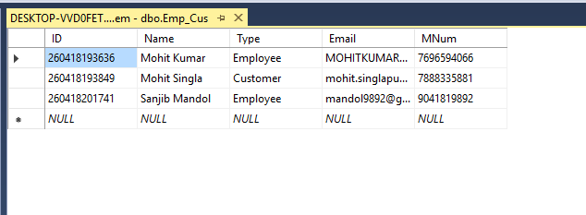

**3.3 Snapshots of system**

1. Home page of Notification System

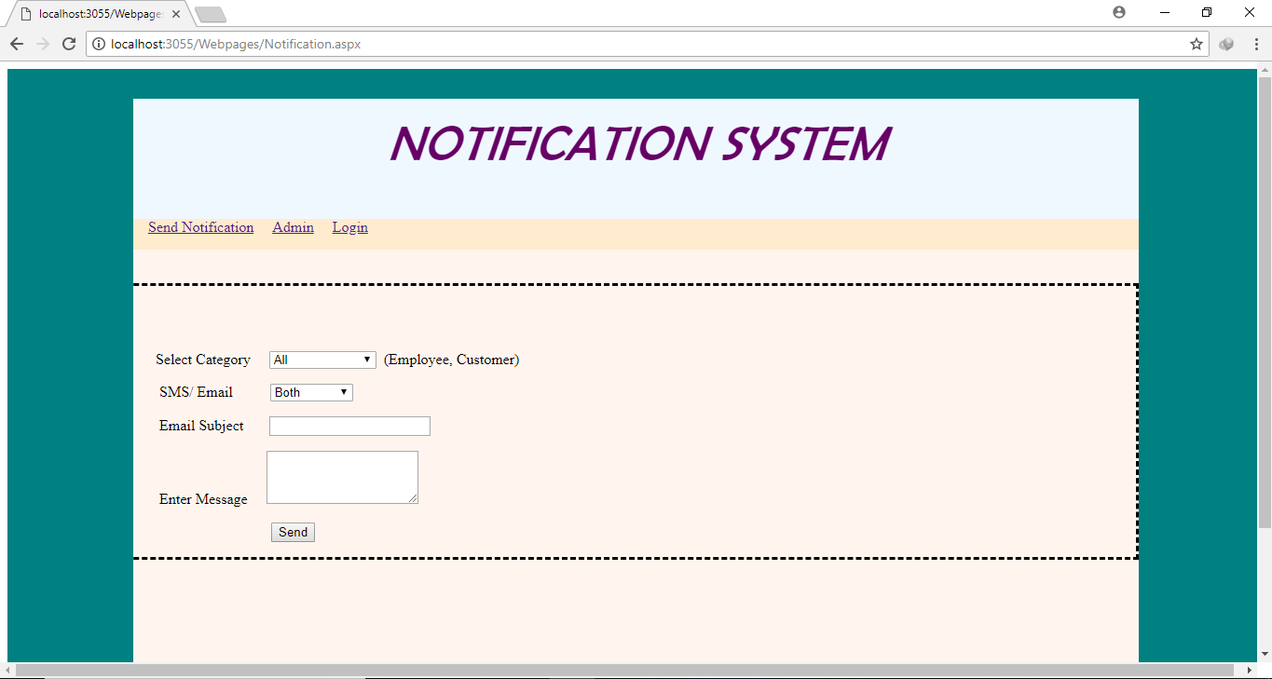

**Admin Login Area:**

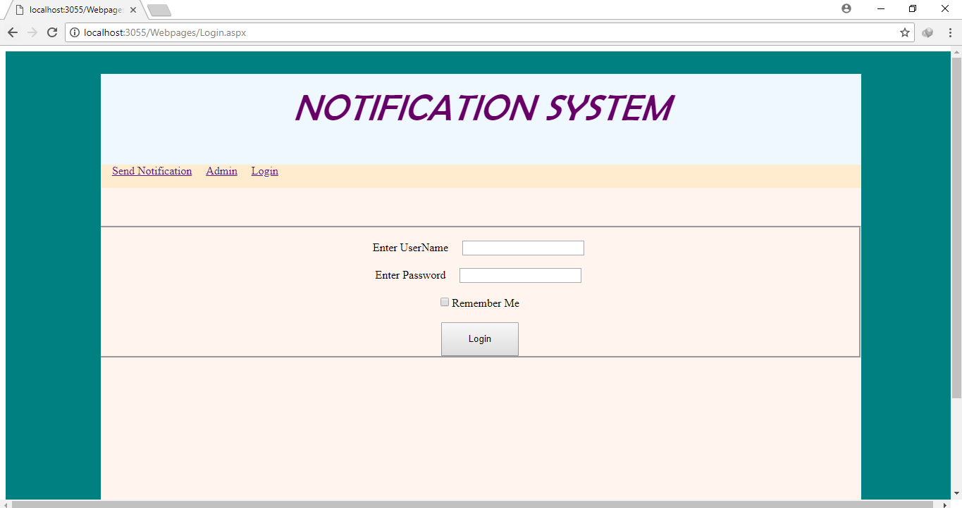

**Adding New Record:**

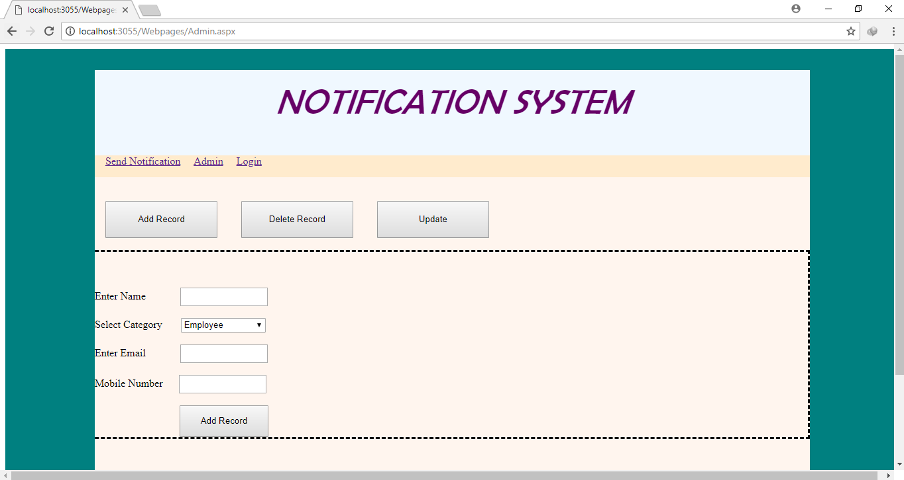

**Deleting Record:**

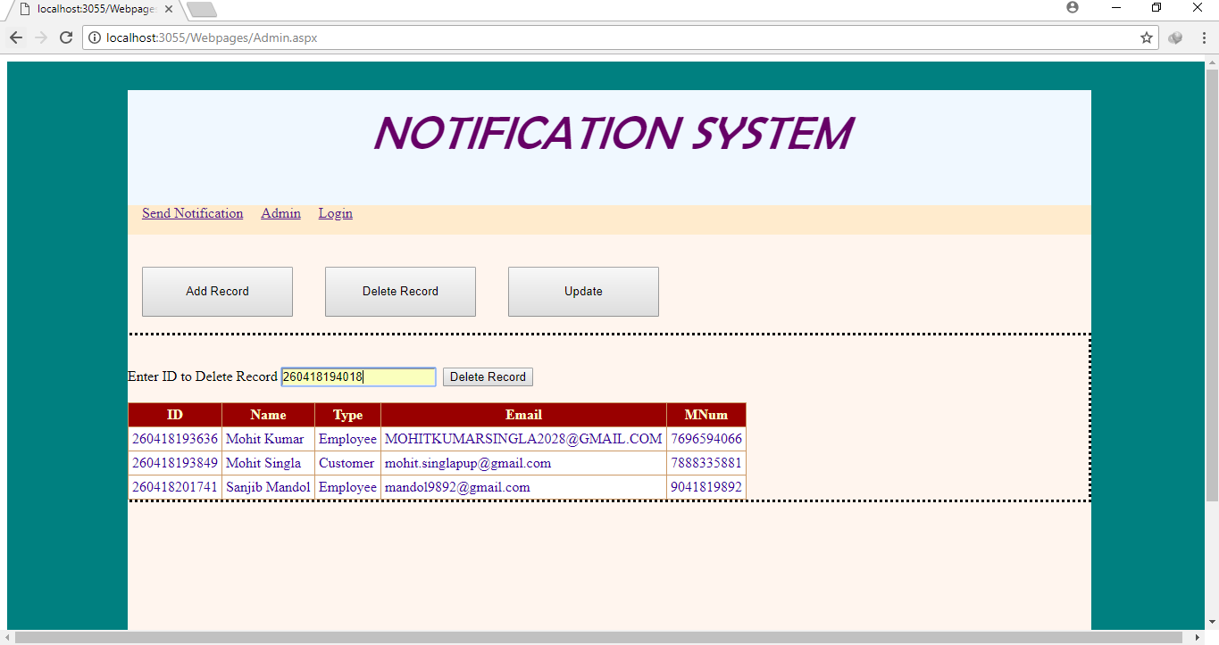

**Update Record:**

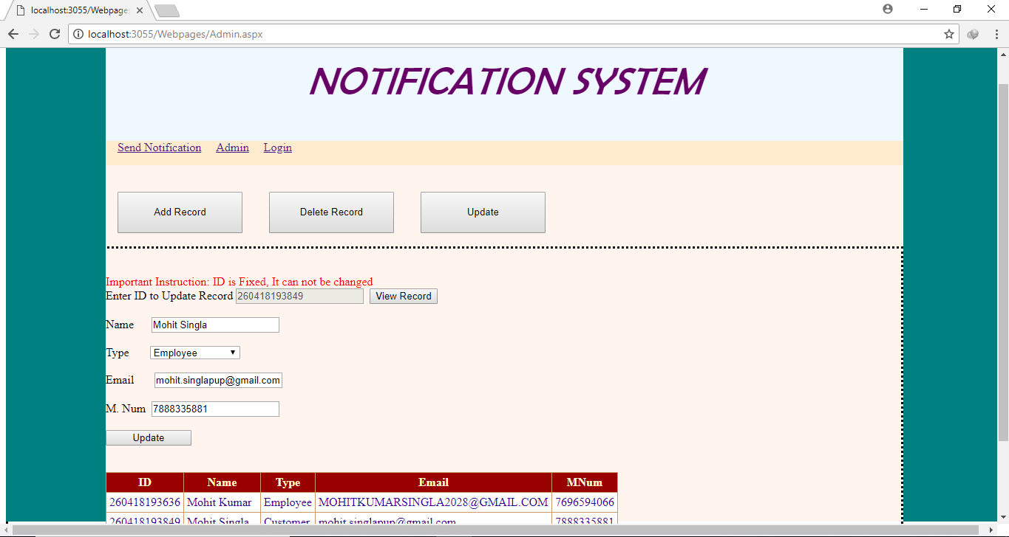

**Chapter 4**

**Testing**

**4.1 Verification**

It is the act of confirming or checking the accuracy. All requirements are fulfilled.

**4.2 Validation**

In this documents process of demonstrates that a system or process meets a define set of requirements.

Our process is validated because it fulfill all requirements.

* User requirements specification
* Functional requirements
* Design specification
* Operational qualification
* Performance qualification
  1. **Testing**

In this the Author performed unit testing and integration testing

**4.3.1 Unit Testing -:**

In this the author performed the testing on each class and find out the error.

* Developed part of the class.
* Complied
* If any error is there?
* Find out the error.
* Remove error.

After removing all these compilation errors, user moved towards to find out logical errors. Then fix all these errors involving syntax, logical and run time errors and move towards further coding.

**4.3.2 Integration Testing -:**

After performing unit testing on each individual class , user moves towards integration testing. The action listeners listens for the events and call appropriate object or not.

There were many problems related to linkage between methods and objects had been discovered and fixed.

**Chapter 5**

**Project legacy**

**5.1 Current Status**



**5.2 Problem faced**

* Searching
* Logic building
* Finding the website providing SMS services
* Finding APIs
* Layout setting

**5.**3  **Limitations**

This system is not store the record of the user.

**5.4 Future enhancements**

**5.5 Conclusion**

In nutshell this system would be useful for those people who want to send notification to the concerned persons or group of persons about related information. Further it will be used to display notifications on home page.

**Reference /Bibliography**

**ASP.NET: The Complete Reference, Matthew MacDonald, McGraw-Hill/ Osborne.**

[https://en.**wikipedia**.org/](https://en.wikipedia.org/)

**Jesse Liberty, Dan Hurwitz: Programming ASP.NET, OReilly.**

<https://www.google.com/>